Nu Bowl Lanes Snack Bar Selections
PIZZA TOPPINGS_______
12 in. cheese..........$9.95 9 inch 12 inch
9 in. cheese............$4.95 add per meat topping - $.75 $1.25
--available toppings— add per non-meat topping - $.50 $1.00
Pepperoni – Sausage – Bacon Add Any Three - $2.00 $3.00
Beef – Banana Peppers – Black Olives
Mushrooms – Jalapeno Peppers
Sandwiches _______
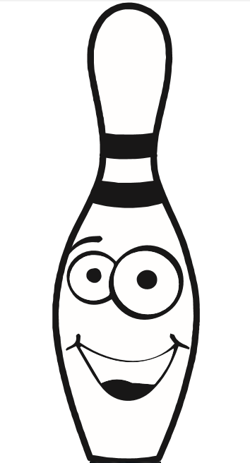
¼ lb Burger..........$3.50 Additions to Sandwiches
Double...............$5.50 Add Cheese - $.50 per choice
Grilled Cheese.....$3.95 (American, Cheddar, Pepperjack)
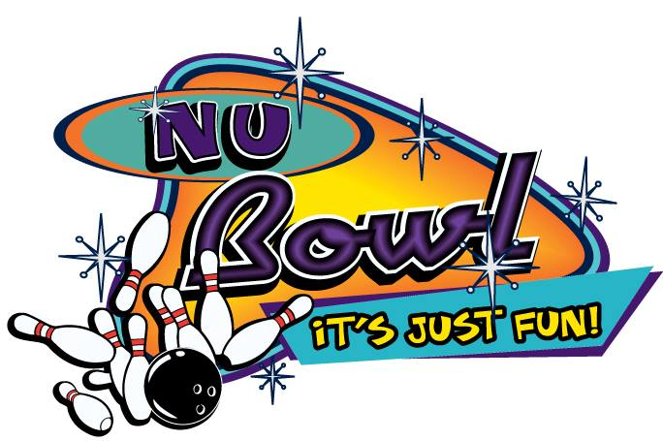
Grilled Chicken...$4.95 Hot sauce dipped or on the side – No charge
Lettuce, Tomato, Pickle, & Onion – No charge
Sauces
Mustard – Ketchup – Mayo
Barbecue – Hot Sauce
Bread Choices – Wheat, White, Bun
Snacks & Sides Salads_____________
Fries.......1 lb. $4.25.....1/2 lb. $2.95 House..........$4.50
Side of Fries w/ a Sandwich....$2.25 Grilled Chicken Salad....6.50
Waffle Fries...........................$3.50 Dressing choices.....Lite Ranch or Creamy Italian
Nachos w/ Cheese.................$3.50 Extra sauces for any items are $.50 each
Chicken Strips w/ choice of sauce....$4.95 Add cheese on fries.......$1.50 or $1.00
Deep Fried Pickle Chips.......$4.25
Pretzel Bites (w/ cinnamon or cheese)....$3.25
___________________________Soft Drinks___________________________
Pepsi – Diet Pepsi – Mt. Dew – Diet Mt. Dew Regular Refills No Ice
Dr. Pepper – Diet Dr. Pepper – Sierra Mist 12 oz $1.25 $1.00 $1.00
Iced Tea (sweet or unsweet) 20 oz $1.75 $1.25 $1.25
Coffee 12 oz.....$1.00 32 oz $2.50 $2.00 $2.00
Pitcher $7.75

